알고리즘 성능
1. KFall
전방낙상 포함여부 | True | False
정확도 | 99.05%(5027/5075) | 99.88%(4135/4140)
민감도 | 98.17%(2303/2346) | 100%(1411/1411)
특이도 | 99.31 %(2683/2729) | 99.82 %(2724/2729)
리드타임 | 302.3±170.3ms | 287.7±155.5ms
Soso(~100ms) | 39 | 124
EarlyDetection(200ms~) | 181 | 15

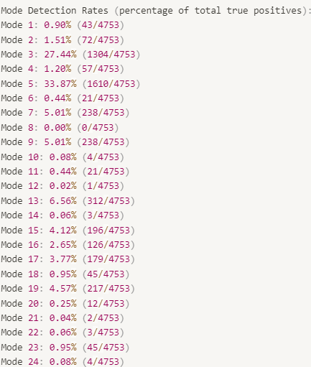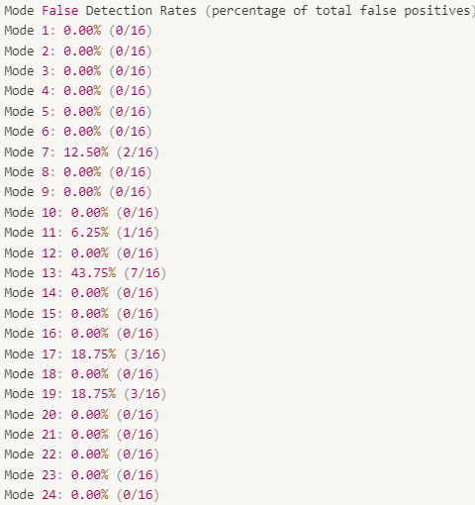

2. Yonsei
전방낙상 포함여부 | True | False
정확도 | 99.15% (928/928) | 100% (744/744)
민감도 | 98.04% (400/408) | 100% (216/216)
특이도 | 100% (528/528) | 100% (528/528)
리드타임 | 132.5±119.2ms | 160.0±105.9ms
Soso | 119 | 42
Early Detection | - | -

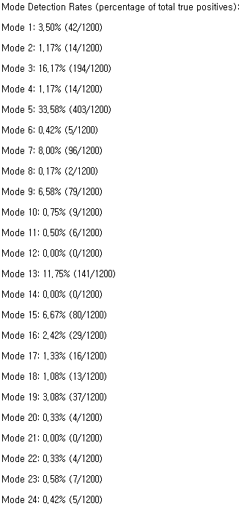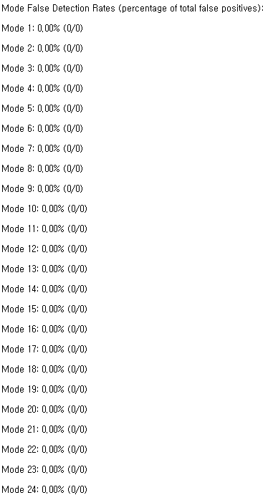
3. 의자 높이에 따른 후방낙상 리드타임
* 각 높이에서 자유낙하시 걸리는 시간은 각각 320ms, 350ms, 380ms이지만, 오히려 의자 높이가 낮을수록 리드타임이 길게 나오는 상반된 결과를 보였음 -> 이는 높이에 대한 두려움으로 발생한 미세한 저항 차이라고 생각됨
* 그래도 모두 충분한 리드타임을 보임
의자 높이 | 1차 | 2차 | 3차
50cm | 300ms | 240ms | 280ms
60cm | 160ms | 240ms | 260ms
70cm | 120ms | 220ms | 120ms

4. 앉다가 넘어지는 타이밍에 따른 후방낙상 리드타임
* 물리적으로 보았을 때, 앉아서 넘어지는 것보다 앉다가 넘어지는 것이 가속이 더 붙어야되고, 수직속도도 빠르고 리드타임도 길게 나와야됨
* 하지만, 인위적으로 넘어지다보니 중간에 멈칫하는 동작이 포함되게 되며, 지면과 반대방향으로 힘이 작용하면서 수직속도가 중간에 감소하는 구간이 발생함
* 해당동작은 넘어지는 타이밍을 맞추는 과정에서 인위적으로 발생한 데이터로 인함이며, 근력이 약한 노인들에게서는 나올 수 없는 동작이라 판단됨
* 물리적으로 보았을 때, 의자 높이 정도 (50cm)에서 앉다가 넘어지는 동작은 문제가 없다고 판단됨
넘어지는 타이밍 | 1차 | 2차 | 3차
50cm | 미검출 | 미검출 | -60ms
60cm | 40ms | 미검출 | 미검출
70cm | -60ms | 100ms | 미검출

5. 최대 수직가속도 비교
* 앉다가 후방낙상 동작이 앉아서 후방낙상 동작에 비하여 낮은 수직속도 값을 보이며, 그나마 높은 수치들을 보인 동작에서는 정상적으로 검출을 함
* 이는 단순히 수직속도가 낮아서 오검출이 되었다라고 해석하는 것이 아닌, 낙상 도중 수직속도가 감소하는 행위가 중간에 들어가서 오검출 되었다라고 해석하는 것이 옳음
 | 앉아서 후방낙상 |  |  | 앉다가 후방낙상
낙상 높이 | 1차 | 2차 | 3차 | 1차 | 2차 | 3차
50cm | 20.06 | 16.92 | 18.03 | 8.21 | 7.74 | 13.29
60cm | 17.86 | 19.99 | 22.21 | 19.14 | 12.2 | 14.07
70cm | 18.56 | 19.97 | 21.98 | 13.41 | 18.44 | 16.66

6. 지면으로 가속을 받는 미끄러지는 동작 리드타임
* 미끄러져 넘어지는 동작들도 200ms 이상의 충분한 리드타임을 보임
1차 | 2차 | 3차
340ms | 280ms | 240ms

7. 최종모델 (파이썬)
def check_conditions2(down, raw_acc, raw_gyro, snr_acc_svm, vv, gyroX, gyroZ):
conditions = [
{'down': None, 'raw_acc': 65, 'raw_gyro': 100, 'snr_acc_svm': 22, 'vv': 4.0, 'gyroX': 190, 'gyroZ': 90,},
{'down': None, 'raw_acc': 60, 'raw_gyro': 120, 'snr_acc_svm': 17, 'vv': 10.5, 'gyroX': 135, 'gyroZ': 90,},
{'down': 95, 'raw_acc': 85, 'raw_gyro': 10, 'snr_acc_svm': 30, 'vv': 2.5, 'gyroX': None, 'gyroZ': None,},
{'down': 90, 'raw_acc': 90, 'raw_gyro': 140, 'snr_acc_svm': 23, 'vv': None, 'gyroX': 45, 'gyroZ': 60,},
{'down': 90, 'raw_acc': 85, 'raw_gyro': 20, 'snr_acc_svm': 23, 'vv': 0.1, 'gyroX': None, 'gyroZ': None,},
{'down': 90, 'raw_acc': 95, 'raw_gyro': 100, 'snr_acc_svm': 18, 'vv': 5.0, 'gyroX': None, 'gyroZ': None,},
{'down': 85, 'raw_acc': 100, 'raw_gyro': 60, 'snr_acc_svm': 30, 'vv': 4.5, 'gyroX': 30, 'gyroZ': 60,},
{'down': 85, 'raw_acc': 80, 'raw_gyro': 80, 'snr_acc_svm': 9.0, 'vv': 4.0, 'gyroX': 30, 'gyroZ': 60,},
{'down': 80, 'raw_acc': 80, 'raw_gyro': 110, 'snr_acc_svm': 20.5, 'vv': 1.0, 'gyroX': 30, 'gyroZ': 25,},
{'down': 80, 'raw_acc': 95, 'raw_gyro': 150, 'snr_acc_svm': 21.5, 'vv': 0.1, 'gyroX': 150, 'gyroZ': 70,},
{'down': 80, 'raw_acc': 110, 'raw_gyro': 15, 'snr_acc_svm': 26.5, 'vv': 7.0, 'gyroX': 100, 'gyroZ': 100,},
{'down': 80, 'raw_acc': 90, 'raw_gyro': 90, 'snr_acc_svm': 25, 'vv': 5.5, 'gyroX': 150, 'gyroZ': 70,},
{'down': 80, 'raw_acc': 80, 'raw_gyro': 40, 'snr_acc_svm': 24, 'vv': 8.0, 'gyroX': None, 'gyroZ': None,},
{'down': 80, 'raw_acc': 75, 'raw_gyro': 150, 'snr_acc_svm': 22, 'vv': 2.0, 'gyroX': 30, 'gyroZ': 25,},
{'down': 75, 'raw_acc': 90, 'raw_gyro': 10, 'snr_acc_svm': 34, 'vv': 1.0, 'gyroX': 100, 'gyroZ': 100,},
{'down': 75, 'raw_acc': 120, 'raw_gyro': 150, 'snr_acc_svm': 17, 'vv': 0.3, 'gyroX': 60, 'gyroZ': 15,},
{'down': 75, 'raw_acc': 120, 'raw_gyro': 30, 'snr_acc_svm': 17, 'vv': 6.0, 'gyroX': 45, 'gyroZ': 40,},
{'down': 70, 'raw_acc': 80, 'raw_gyro': 40, 'snr_acc_svm': 26, 'vv': 3.5, 'gyroX': 100, 'gyroZ': 100,},
{'down': 70, 'raw_acc': 80, 'raw_gyro': 40, 'snr_acc_svm': 19, 'vv': 5.0, 'gyroX': 60, 'gyroZ': 20,},
{'down': 70, 'raw_acc': 75, 'raw_gyro': 70, 'snr_acc_svm': 22.5, 'vv': 1.5, 'gyroX': 140, 'gyroZ': 85,},
{'down': 70, 'raw_acc': 30, 'raw_gyro': 50, 'snr_acc_svm': 10, 'vv': 14.0, 'gyroX': None, 'gyroZ': None,},
{'down': 65, 'raw_acc': 70, 'raw_gyro': 40, 'snr_acc_svm': 20, 'vv': 4.5, 'gyroX': 180, 'gyroZ': 60,},
{'down': 60, 'raw_acc': 85, 'raw_gyro': 65, 'snr_acc_svm': 19.0, 'vv': 5.0, 'gyroX': 200, 'gyroZ': 30,},
{'down': 55, 'raw_acc': 60, 'raw_gyro': 80, 'snr_acc_svm': 18, 'vv': 5.5, 'gyroX': 200, 'gyroZ': 30,},
]

detected_modes = []
for idx, cond in enumerate(conditions):
if (
(
(cond['gyroX'] is None or gyroX/65.536 > cond['gyroX']) and
(cond['down'] is None or down >= cond['down']) and
(cond['raw_acc'] is None or raw_acc < cond['raw_acc']) and
(cond['raw_gyro'] is None or raw_gyro > cond['raw_gyro']) and
snr_acc_svm < cond['snr_acc_svm'] and
(cond['vv'] is None or vv > cond['vv'])) or

(
(cond['gyroX'] is None or gyroX/65.536 < cond['gyroX']) and
(cond['gyroZ'] is None or abs(gyroZ/65.536) > cond['gyroZ']) and
(cond['down'] is None or down >= cond['down']) and
(cond['raw_acc'] is None or raw_acc < cond['raw_acc']) and
(cond['raw_gyro'] is None or raw_gyro > cond['raw_gyro']) and
snr_acc_svm < cond['snr_acc_svm'] and
(cond['vv'] is None or vv > cond['vv']))
):
detected_modes.append(idx + 1) # 모드 인덱스는 1부터 시작
return detected_modes

8. 최종모델 (C)
if (ptc->raw_acc < 65 && ptc->raw_gyro > 100 && ptc->signal_noise < 22.0f && ptc->vel_v > 4.0f && ptc->gyroX > 190 ) {
pObj->snr_counter++;
if (pObj->snr_counter >= 3) {
return 1;
}
}

else if (ptc->raw_acc < 65 && ptc->raw_gyro > 100 && ptc->signal_noise < 22.0f && ptc->vel_v > 4.0f && ptc->gyroX < 190 && ptc->gyroZ > 90) {
pObj->snr_counter++;
if (pObj->snr_counter >= 3) {
return 1;
}
}
else if (ptc->raw_acc < 60 && ptc->raw_gyro > 120 && ptc->signal_noise < 17.0f && ptc->vel_v > 10.5f && ptc->gyroX > 135) {
pObj->snr_counter++;
if (pObj->snr_counter >= 3) {
return 2;
}
}

else if (ptc->raw_acc < 60 && ptc->raw_gyro > 120 && ptc->signal_noise < 17.0f && ptc->vel_v > 10.5f && ptc->gyroX < 135 && ptc->gyroZ > 90) {
pObj->snr_counter++;
if (pObj->snr_counter >= 3) {
return 2;
}
}
else if (*ptf >= 0.55f) {

if (*ptf < 0.60f) {
goto down_decision_upper_55;
}
else if (*ptf < 0.65f) {
goto down_decision_upper_60;
}
else if (*ptf < 0.70f) {
goto down_decision_upper_65;
}
else if (*ptf < 0.75f) {
goto down_decision_upper_70;
}
else if (*ptf < 0.80f) {
goto down_decision_upper_75;
}
else if (*ptf < 0.85f) {
goto down_decision_upper_80;
}
else if (*ptf < 0.90f) {
goto down_decision_upper_85;
}
else if (*ptf < 0.95f) {
goto down_decision_upper_90;
}

else {
goto down_decision_upper_95;
}
}
else {
if (pObj->snr_counter > 0) {
pObj->snr_counter = 0;
}
return 0;
}
return 0;

down_decision_upper_95:
if (ptc->raw_acc < 85 && ptc->raw_gyro > 10 && ptc->signal_noise < 30.0f && ptc->vel_v > 2.5f) {
pObj->snr_counter++;

if (pObj->snr_counter >= 3) {
return 3;
}
}

else {
goto down_decision_upper_90;
}

return 0;

down_decision_upper_90:
if (ptc->raw_acc < 90 && ptc->raw_gyro > 140 && ptc->signal_noise < 23.0 && ptc->gyroX > 45) {
pObj->snr_counter++;

if (pObj->snr_counter >= 3) {
return 4;
}
}
else if (ptc->raw_acc < 90 && ptc->raw_gyro > 140 && ptc->signal_noise < 23.0f && ptc->gyroX < 45 && ptc->gyroZ > 60) {
pObj->snr_counter++;
if (pObj->snr_counter >= 3) {
return 4;
}
}
else if (ptc->raw_acc < 85 && ptc->raw_gyro > 20 && ptc->signal_noise < 23.0f && ptc->vel_v > 0.1f) {
pObj->snr_counter++;

if (pObj->snr_counter >= 3) {
return 5;
}
}
else if (ptc->raw_acc < 95 && ptc->raw_gyro > 100 && ptc->signal_noise < 18.0f && ptc->vel_v > 5.0f) {
pObj->snr_counter++;

if (pObj->snr_counter >= 3) {
return 6;
}
}
else {
goto down_decision_upper_85;
}

return 0;

down_decision_upper_85:
if (ptc->raw_acc < 100 && ptc->raw_gyro > 60 && ptc->signal_noise < 30.0f && ptc->vel_v > 4.5f && ptc->gyroX > 30) {
pObj->snr_counter++;

if (pObj->snr_counter >= 3) {
return 7;
}
}
else if (ptc->raw_acc < 100 && ptc->raw_gyro > 60 && ptc->signal_noise < 30.0f && ptc->vel_v > 4.5f && ptc->gyroX < 30 && ptc->gyroZ > 60) {

pObj->snr_counter++;
if (pObj->snr_counter >= 3) {
return 7;
}
}
else if (ptc->raw_acc < 80 && ptc->raw_gyro > 80&& ptc->signal_noise < 9.0f && ptc->vel_v > 4.0f && ptc->gyroX > 30) {
pObj->snr_counter++;

if (pObj->snr_counter >= 3) {
return 8;
}
}
else if (ptc->raw_acc < 80 && ptc->raw_gyro > 80 && ptc->signal_noise < 9.0f && ptc->vel_v > 4.0f && ptc->gyroX < 30 && ptc->gyroZ > 60) {

pObj->snr_counter++;
if (pObj->snr_counter >= 3) {
return 8;
}
}
else {
goto down_decision_upper_80;
}
return 0;

down_decision_upper_80:
if (ptc->raw_acc < 80 && ptc->raw_gyro > 110 && ptc->signal_noise < 20.5f && ptc->vel_v > 1.0f && ptc->gyroX > 30) {
pObj->snr_counter++;

if (pObj->snr_counter >= 3) {
return 9;
}
}
else if (ptc->raw_acc < 80 && ptc->raw_gyro > 110 && ptc->signal_noise < 20.5f && ptc->vel_v > 1.0f && ptc->gyroX < 30 && ptc->gyroZ > 25) {

pObj->snr_counter++;
if (pObj->snr_counter >= 3) {
return 9;
}
}
else if (ptc->raw_acc < 95 && ptc->raw_gyro > 150 && ptc->signal_noise < 21.5f && ptc->vel_v > 0.1f && ptc->gyroX > 150) {
pObj->snr_counter++;

if (pObj->snr_counter >= 3) {
return 10;
}
}
else if (ptc->raw_acc < 95 && ptc->raw_gyro > 150 && ptc->signal_noise < 21.5f && ptc->vel_v > 0.1f && ptc->gyroX < 150 && ptc->gyroZ > 70) {

pObj->snr_counter++;
if (pObj->snr_counter >= 3) {
return 10;
}
}
else if (ptc->raw_acc < 110 && ptc->raw_gyro > 15 && ptc->signal_noise < 26.5f && ptc->vel_v > 7.0f && ptc->gyroX > 100) {

pObj->snr_counter++;
if (pObj->snr_counter >= 3) {
return 11;
}
}
else if (ptc->raw_acc < 110 && ptc->raw_gyro > 15 && ptc->signal_noise < 26.5f && ptc->vel_v > 7.0f && ptc->gyroX < 100 && ptc->gyroZ > 100) {

pObj->snr_counter++;
if (pObj->snr_counter >= 3) {
return 11;
}
}
else if (ptc->raw_acc < 90 && ptc->raw_gyro > 90 && ptc->signal_noise < 25.0f && ptc->vel_v > 5.5f && ptc->gyroX > 150) {
pObj->snr_counter++;

if (pObj->snr_counter >= 3) {
return 12;
}
}
else if (ptc->raw_acc < 90 && ptc->raw_gyro > 90 && ptc->signal_noise < 25.0f && ptc->vel_v > 5.5f && ptc->gyroX < 150 && ptc->gyroZ > 70) {

pObj->snr_counter++;
if (pObj->snr_counter >= 3) {
return 12;
}
}
else if (ptc->raw_acc < 80 && ptc->raw_gyro > 40 && ptc->signal_noise < 24.0f && ptc->vel_v > 8.0f) {
pObj->snr_counter++;

if (pObj->snr_counter >= 3) {
return 13;
}
}
else if (ptc->raw_acc < 75 && ptc->raw_gyro > 150 && ptc->signal_noise < 22.0f && ptc->vel_v > 2.0f && ptc->gyroX > 30) {

pObj->snr_counter++;
if (pObj->snr_counter >= 3) {
return 14;
}
}
else if (ptc->raw_acc < 75 && ptc->raw_gyro > 150 && ptc->signal_noise < 22.0f && ptc->vel_v > 2.0f && ptc->gyroX < 30 && ptc->gyroZ > 25) {

pObj->snr_counter++;
if (pObj->snr_counter >= 3) {
return 14;
}
}

else {
goto down_decision_upper_75;
}
return 0;

down_decision_upper_75:

if (ptc->raw_acc < 90 && ptc->raw_gyro > 10 && ptc->signal_noise < 34.0f && ptc->vel_v > 1.0f && ptc->gyroX > 100) {
pObj->snr_counter++;
if (pObj->snr_counter >= 3) {
return 15;
}
}
else if (ptc->raw_acc < 90 && ptc->raw_gyro > 10 && ptc->signal_noise < 34.0f && ptc->vel_v > 1.0f && ptc->gyroX < 100 && ptc->gyroZ > 100) {
pObj->snr_counter++;
if (pObj->snr_counter >= 3) {
return 15;
}
}

else if (ptc->raw_acc < 120 && ptc->raw_gyro > 150 && ptc->signal_noise < 17.0f && ptc->vel_v > 0.3f && ptc->gyroX > 60) {
pObj->snr_counter++;

if (pObj->snr_counter >= 3) {
return 16;
}
}
else if (ptc->raw_acc < 120 && ptc->raw_gyro > 150 && ptc->signal_noise < 17.0f && ptc->vel_v > 0.3f && ptc->gyroX < 60 && ptc->gyroZ > 15) {
pObj->snr_counter++;
if (pObj->snr_counter >= 3) {
return 16;
}
}
else if (ptc->raw_acc < 120 && ptc->raw_gyro > 30 && ptc->signal_noise < 17.0f && ptc->vel_v > 6.0f && ptc->gyroX > 45) {
pObj->snr_counter++;
if (pObj->snr_counter >= 3) {
return 17;
}
}

else if (ptc->raw_acc < 120 && ptc->raw_gyro > 30 && ptc->signal_noise < 17.0f && ptc->vel_v > 6.0f && ptc->gyroX < 45 && ptc->gyroZ > 40) {

pObj->snr_counter++;
if (pObj->snr_counter >= 3) {
return 17;
}
}

else {
goto down_decision_upper_70;
}
return 0;

down_decision_upper_70:

if (ptc->raw_acc < 80 && ptc->raw_gyro > 40 && ptc->signal_noise < 26.0f && ptc->vel_v > 3.5f && ptc->gyroX > 100) {
pObj->snr_counter++;
if (pObj->snr_counter >= 3) {
return 18;
}
}
else if (ptc->raw_acc < 80 && ptc->raw_gyro > 40 && ptc->signal_noise < 26.0f && ptc->vel_v > 3.5f && ptc->gyroX < 100 && ptc->gyroZ > 100) {
pObj->snr_counter++;
if (pObj->snr_counter >= 3) {
return 18;
}
}
else if (ptc->raw_acc < 80 && ptc->raw_gyro > 40 && ptc->signal_noise < 19.0f && ptc->vel_v > 5.0f && ptc->gyroX > 60) {
pObj->snr_counter++;

if (pObj->snr_counter >= 3) {
return 19;
}
}
else if (ptc->raw_acc < 80 && ptc->raw_gyro > 40 && ptc->signal_noise < 19.0f && ptc->vel_v > 5.0f && ptc->gyroX < 60 && ptc->gyroZ > 20) {
pObj->snr_counter++;
if (pObj->snr_counter >= 3) {
return 19;
}
}
else if (ptc->raw_acc < 75 && ptc->raw_gyro > 70 && ptc->signal_noise < 22.5f && ptc->vel_v > 1.5f && ptc->gyroX > 140) {
pObj->snr_counter++;

if (pObj->snr_counter >= 3) {
return 20;
}
}
else if (ptc->raw_acc < 75 && ptc->raw_gyro > 70 && ptc->signal_noise < 22.5f && ptc->vel_v > 1.5f && ptc->gyroX < 140 && ptc->gyroZ > 85) {
pObj->snr_counter++;
if (pObj->snr_counter >= 3) {
return 20;
}
}
else if (ptc->raw_acc < 30 && ptc->raw_gyro > 50 && ptc->signal_noise < 10.0f && ptc->vel_v > 14.0f) {
pObj->snr_counter++;

if (pObj->snr_counter >= 3) {
return 21;
}
}

else {
goto down_decision_upper_65;
}
return 0;

down_decision_upper_65:

if (ptc->raw_acc < 70 && ptc->raw_gyro > 40 && ptc->signal_noise < 20.0f && ptc->vel_v >4.5f && ptc->gyroX > 180) {
pObj->snr_counter++;

if (pObj->snr_counter >= 3) {
return 22;
}
}
else if (ptc->raw_acc < 85 && ptc->raw_gyro > 70 && ptc->signal_noise < 19.0f && ptc->vel_v > 5.0f && ptc->gyroX < 180 && ptc->gyroZ > 60) {
pObj->snr_counter++;
if (pObj->snr_counter >= 3) {
return 22;
}
}
else {
goto down_decision_upper_60;
}
return 0;

down_decision_upper_60:
if (ptc->raw_acc < 85 && ptc->raw_gyro > 65 && ptc->signal_noise < 19.0f && ptc->vel_v > 5.0f && ptc->gyroX > 200) {
pObj->snr_counter++;

if (pObj->snr_counter >= 3) {
return 23;
}
}
else if (ptc->raw_acc < 85 && ptc->raw_gyro > 65 && ptc->signal_noise < 19.0f && ptc->vel_v > 5.0f && ptc->gyroX < 200 && ptc->gyroZ > 30) {
pObj->snr_counter++;
if (pObj->snr_counter >= 3) {
return 23;
}
}
else {
goto down_decision_upper_55;
}
return 0;

down_decision_upper_55:
if (ptc->raw_acc < 60 && ptc->raw_gyro > 80 && ptc->signal_noise < 18.0f && ptc->vel_v > 5.5f && ptc->gyroX > 200) {
pObj->snr_counter++;

if (pObj->snr_counter >= 3) {
return 24;
}
}
else if (ptc->raw_acc < 60 && ptc->raw_gyro > 80 && ptc->signal_noise < 18.0f && ptc->vel_v > 5.5f && ptc->gyroX < 200 && ptc->gyroZ > 30) {
pObj->snr_counter++;
if (pObj->snr_counter >= 3) {
return 24;
}
}
else {
if (pObj->snr_counter > 0) {
pObj->snr_counter = 0;
}
return 0;
}
return 0;

